
EMATM0067 Introduction to AI and Text Analytics
Group Report- Comparative Corpus Analysis


1. Abstract
This project investigates how the focus, framing, and communication of machine learning research have evolved over time using a comparative corpus analysis of arXiv abstracts from the cs.LG category. The analysis of the abstracts covers the dates 1999 to 2021 and divides them into three sections: early development (1999–2010), growth phase (2011-2015), and deep learning boom (2016-2021). A text analytics pipeline was devised with TF-IDF, Latent Dirichlet Allocation (LDA), BERTopic, and Hierarchical Dirichlet Process (HDP) to compare other text representations and other topic modelling methods. PCA was further used to visualise temporal drift in the research theme over time. The findings indicate that a significant shift in the theoretical and kernel-based procedures towards the neural networks, graph learning, reinforcement learning, and federated learning is realised. BERTopic using KMeans clustering also generated the most consistent and interpretable topics, whereas LDA offered a high level of temporal consistency and TF-IDF effectively represented changes in vocabulary.

Table of Contents
1. Abstract 1
2. Introduction 3
2.1 Background and Motivation 3
2.2 Task Overview 3
2.3 Research Objectives 3
2.4 Requirements for a Good Solution 4
3. Methods 4
3.1 Overview of the Text Analysis Pipeline 4
3.2 Baseline System: TF-IDF Representation 5
3.2.1 Preprocessing Strategy 5
3.2.2 TF-IDF as the Baseline 5
3.3 Axes of Experimentation 6
3.3.1 Axis 1: Text Representation 6
3.3.2 Axis 2: Comparison Method 7
3.4 Recommended Enhancements Cross-Methods 7
3.4.1 LDA Topic Modelling 7
3.4.2 BERTopic 7
3.4.3 HDP Topic Modelling 8
3.5 PCA for Temporal Drift Analysis 8
3.6 How Methods Change Insights 9
4. Experimental Evaluation 9
4.1 Evaluation Criteria and Performance Measures 9
4.2 Experimental Setup 10
4.3 Results and Comparative Findings 11
4.3.1 TF-IDF Results 11
4.3.2 LDA Results 11
4.3.3 BERTopic Results 13
4.3.4 HDP Results 15
4.4 Error Analysis and Method Limitations 16
5. Conclusions 17

2. Introduction

2.1 Background and Motivation
Scientific abstracts provide a concise summary of research contributions and reflect how researchers frame problems, communicate novelty, and highlight methodological advances. In rapidly evolving domains such as Artificial Intelligence (AI), Machine Learning (ML), and Natural Language Processing (NLP), analysing abstracts over time can reveal important shifts in research priorities, dominant methods, and scientific language. The transformations are useful in determining how a particular field has grown out of its theoretical roots into a specialised field and new paradigms. The field of machine learning, in particular, has undergone a remarkable change during the last two decades. Initial studies placed a lot of emphasis on statistical learning theory, optimisation, kernel methods and classification models i.e. Support Vector Machines (SVMs). Contrastingly, in recent years, deep learning, graph neural networks, reinforcement learning, federated learning, and large-scale data-driven models have dominated the learning field. This study of this transformation using methodical corpus research yields helpful information to the intellectual history of the field. This project seeks to conduct a comparative corpus analysis of the machine learning abstracts to study the ways in which the research themes and communication patterns have evolved over the years.

2.2 Task Overview
The coursework requires the design and implementation of a text analysis pipeline capable of analysing temporal changes within a scientific corpus. The primary aim is to find out how the focus and framing of research changed and what the analytical analysis of various research techniques can reveal.
The study focuses specifically on the arXiv dataset from the HuggingFace repository, using abstracts from the cs.LG (Machine Learning) group. The corpus was built using metadata in the form of title, year of publication, and abstract. The year of publication was harvested using the arXiv identifiers, which simply allow the temporal segmentation of the dataset. To support meaningful comparison, the corpus was divided into three periods: 1999–2010 (early stage), 2011–2015 (growth stage), and 2016–2021 (boom stage). These eras are key growth stages of machine learning study and facilitate a systematic foundation to examine temporal drift.

2.3 Research Objectives
The main objectives of this study are:
- To analyse how the focus, framing, and communication of machine learning research abstracts have changed over time using the arXiv cs.LG corpus.
- To divide the corpus into three temporal periods (1999–2010, 2011–2015, and 2016–2021) and compare the dominant research themes across these stages.
- To evaluate different text representation approaches, including TF-IDF, LDA, HDP, and BERTopic, for identifying temporal changes in scientific abstracts.
- To compare keyword-based, probabilistic topic modelling, and embedding-based topic modelling methods in terms of interpretability, robustness, and consistency of findings.
- To apply Principal Component Analysis (PCA) for visualising temporal drift and identifying major shifts in research directions across periods.
- To assess the strengths and limitations of each analytical method and determine which approach provides the most meaningful insights into the evolution of machine learning research.
- To provide evidence-based conclusions regarding the transition from traditional machine learning methods toward deep learning, graph learning, reinforcement learning, and specialised modern applications.

2.4 Requirements for a Good Solution
A good solution should show good preprocessing, significant temporal segmentation, explicit comparison among techniques, and high interpretation of results. It must also assess conformity across methods of analysis and make sure that patterns discovered are compatible with other known advances in the field of machine learning. Therefore, this study combines quantitative topic modelling with qualitative interpretation to provide a comprehensive understanding of how machine learning research evolved from foundational theoretical work to the modern era dominated by deep learning and specialised applications.

3. Methods

3.1 Overview of the Text Analysis Pipeline
This research project was to develop a comparative text analytics pipeline to understand how machine learning research abstracts have evolved over the years. The arXiv cs was analyzed based on the abstracts.LG (Machine Learning) category and explored lexical, thematic, and semantic changes across three time periods: 1999–2010 (early stage), 2011–2015 (growth stage), and 2016–2021 (boom stage). To capture significant developmental stages of machine learning, including the foundations of theoretical concepts and the accelerated growth of deep learning and areas of specialisation.
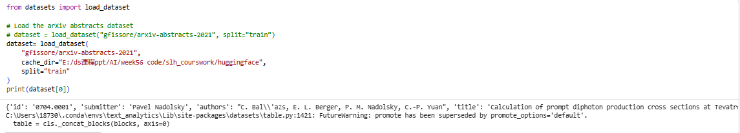
Figure 1: Load Dataset
The pipeline was composed of five key steps: data collection, preprocessing, temporal segmentation, topic modelling, and comparative evaluation. First, abstracts were extracted from the arXiv dataset and filtered to retain only submissions from the cs.LG category. The years of publication were identified by means of arXiv identifiers, which allowed splitting the corpus into the three defined periods.
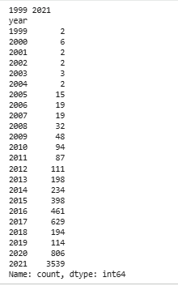
Figure 2: Dataset Overview
Various text presentation methods were then used to make comparisons on how different methods illustrated temporal variations. The baseline lexical strategy was TF-IDF, whereas the topic modelling strategies were LDA, HDP and BERTopic. Principal Component Analysis (PCA) was also used to visualise the existence of the temporal drift as the abstracts are projected to the lower-dimensional space. This multi-method design enhanced robustness and enabled a more robust comparison across analytical methods.

3.2 Baseline System: TF-IDF Representation

3.2.1 Preprocessing Strategy
Another significant step was preprocessing since the quality of the input text is a significant determinant of the topic quality. In the case of TF-IDF and LDA, an entire data preprocessing pipeline was executed with the help of NLTK. This involved the text to lowercase, excluding punctuations, tokenisation, stopword elimination and lemmatisation.
This deleted common stopwords like the, and, and of because they add little useful analysis and can skew the measures based on frequency. Lemmatisation existed to shorten a word to root form to enhance the consistency of the words across the documents and to decrease the sparseness of the document-term matrix. One example is where the words learning and learned were considered similar to the root word learning.
Both unigram and bigram feature were designed. Unigrams were effective in capturing single important words, whereas bigrams enhanced specificity through identifying common technical phrases such as those that refer to neural network, reinforcement learning and support vector. In the case of BERTopic, less lengthy preprocessing was implemented since embedding-based models have a greater ability to conserve semantic meaning when both contextual sentence structure and embedding are maintained. Overcleaning may also decrease the quality of embedding, so minimal stopword processing has been implemented.

3.2.2 TF-IDF as the Baseline
TF-IDF was chosen as the baseline technique since it provides a simple, transparent, and highly readable method of identifying a change in vocabulary over time. It brings out words appearing frequently in a document but not frequently in the entire corpus, and it has found its way in identifying the unique language of research.
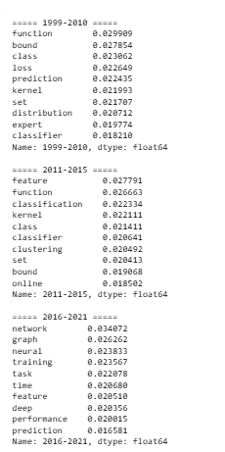
Figure 3: Mean TF-IDF for each Periods
The overall TF-IDF means across the temporal periods were obtained to determine the prevailing keywords and phrases. The cases of the three periods were then compared using distinctive terms to see changes in vocabulary. Cosine similarity and distance matrices were also utilized as a measure of how closely the periods resembled in relation to the lexical usage. This base allowed one to directly see how theoretical concepts, such as the terms of etic or ecstatic in early theory, are directly replaced by terms such as the term of neural in initial theory in deep learning terms.

3.3 Axes of Experimentation

3.3.1 Axis 1: Text Representation
The former axis was aimed at comparing four text representation strategies, namely TF-IDF, LDA, HDP, and BERTopic. The TF-IDF was anticipated to work well in identifying the vocabulary changes, though limited in detecting semantic associations among related words. LDA has been chosen to model latent topics, which can be determined, and more global thematic change can be detected across periods. HDP was also incorporable due to its automatic count of subjects, which also lessens the manual process of selecting the parameters. It was expected that BERTopic would be provided with the highest semantic coherence as the tool utilizes transformer-based sentence embedding and clustering methods instead of only paying attention to the frequency of words.
Table 1: Comparative Design of Methods and Hypotheses
Method | Main Purpose | Strength Expected | Limitation Expected | Hypothesis
TF-IDF | Vocabulary comparison | Clear lexical interpretation | Weak semantic understanding | Strong for detecting keyword drift
LDA | Topic evolution | Stable topic discovery | Requires manual topic tuning | Bigrams improve topic clarity
BERTopic | Semantic topic modelling | High topic coherence | Sensitive to clustering settings | Best semantic interpretability

3.3.2 Axis 2: Comparison Method
The second axis was based on the comparison of different periods based on various methods of analysis. It used three methods: TF-IDF analysis of the keywords, topic modelling analysis of the topic evolution, and PCA analysis of dimensional reduction. The analysis of the keywords was devoted to determining the dominating words and the peculiarities of the vocabulary alteration. Topic modelling explored changes in the overarching research topics over time. As visual evidence of the fact of temporal drift, PCA projected abstracts into two-dimensional space and indicated whether subsequent research occupied different areas than the previous research.

3.4 Recommended Enhancements Cross-Methods

3.4.1 LDA Topic Modelling
LDA was implemented both separately for each period and globally across the full corpus. This allowed comparison between local topic evolution and global thematic consistency across the entire dataset. Ten topics were initially tested for each period, with topic coherence examined manually to improve interpretability. Both unigram and bigram models were compared. Unigram models captured general research terms, but bigram models significantly improved specificity by preserving technical phrases such as “support vector,” “neural network,” and “reinforcement learning.” This reduced ambiguity and improved topic labelling. The hypothesis was that bigram LDA would provide clearer boundaries between traditional machine learning themes and modern deep learning topics. This was confirmed by stronger interpretability and more consistent topic separation across time periods.
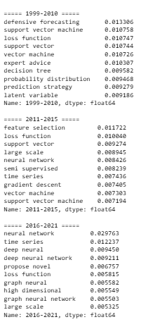
Figure 4: ngram Mean TF_IDF
The unigram and bigram versions were put to the test. The hypothesis of the main improvement was that bigrams would enhance topic clarity by better formulating technical phrases. As an illustration, support vector makes more sense than analysing support and vector individually.

3.4.2 BERTopic
As the most developed semantic modelling tool, BERTopic was announced. It takes sentence embeddings, uses dimensionality reduction, and clustering to form semantically coherent topics. Compared to LDA, BERTopic can cluster documents according to the contextual meaning, as opposed to just shared keywords. This enables one to identify similar research themes even though the authors may employ different vocabulary. Various settings were experimented with such as baseline BERTopic, outlier removal, K-Means clustering, and MPNet embeddings. The hypothesis was that KMeans clustering would enhance topic stability and minimize excessive outlier assignments which tend to be very high with default clustering algorithms.

3.4.3 HDP Topic Modelling
HDP was included as a non-parametric extension of LDA that automatically determines the number of topics. This was expected to improve flexibility because topic complexity may vary across different time periods. However, there was also a hypothesis that this flexibility could reduce interpretability by producing fragmented or overlapping topics. HDP was therefore mainly used as a comparative benchmark against manually tuned LDA and BERTopic.

3.5 PCA for Temporal Drift Analysis
Principal Component Analysis (PCA) was applied to both TF-IDF vectors and embedding-based representations to visualise how machine learning research changed over time. PCA reduced the high-dimensional text space into two principal components, allowing abstracts from different periods to be plotted in a two-dimensional space. The purpose was to examine whether research from different periods formed separate clusters. If strong temporal drift existed, early abstracts would cluster around theoretical work such as optimisation, classification, and kernel methods, while later abstracts would shift toward deep learning, graph learning, and application-driven research.
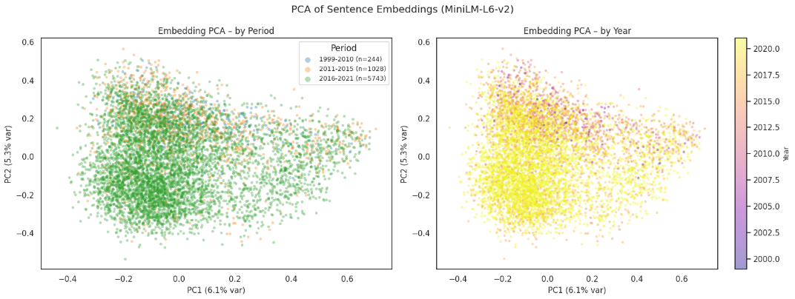
Figure 5: PCA of Sentence Embeddings
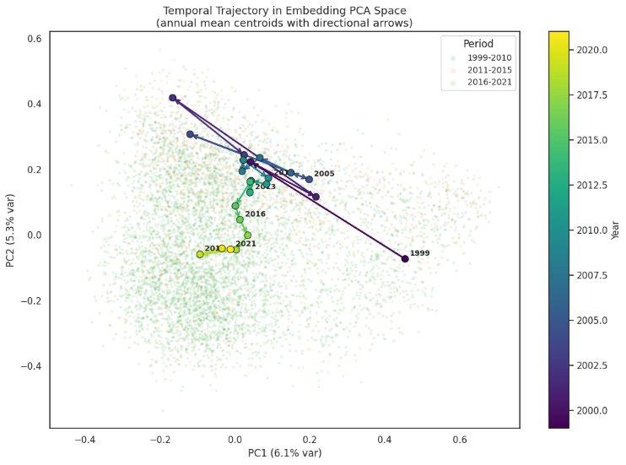
Figure 6: Temporal Trajectory in Embedding PCA Space
The PCA plots showed a gradual movement rather than complete separation. Abstracts from 1999–2010 formed tighter clusters around classical machine learning themes, while 2016–2021 abstracts occupied broader and more distinct regions, reflecting diversification and expansion of research areas. The 2011–2015 period acted as a transition zone between these two extremes. This demonstrates that the field evolved progressively rather than through sudden disruption, supporting the findings from TF-IDF and topic modelling.

3.6 How Methods Change Insights
An important finding of this study is that different analytical methods produce different types of insight rather than identical conclusions. TF-IDF mainly highlights surface-level vocabulary changes and is most effective for identifying shifts in research terminology, such as the decline of words like “kernel” and “classification” and the rise of terms such as “neural,” “graph,” and “deep.” LDA moves beyond keywords and helps explain how broader research themes evolve across time, showing transitions from statistical learning toward reinforcement learning and graph neural networks. BERTopic provides stronger semantic understanding by grouping conceptually similar abstracts even when authors use different wording, making specialised topics easier to interpret. HDP contributes exploratory flexibility by automatically identifying topic numbers, but with weaker clarity. Therefore, each method changes the final interpretation by focusing on vocabulary, themes, semantic meaning, or exploratory topic discovery.

4. Experimental Evaluation

4.1 Evaluation Criteria and Performance Measures
The purpose of the experimental evaluation was not traditional predictive accuracy, but the comparative assessment of how effectively different text analytics methods captured temporal changes in machine learning research.
Table 2: Comparative Evaluation of Methods
Method | Main Purpose | Interpretability | Strength | Limitation | Final Insight
TF-IDF | Vocabulary comparison | High | Clear lexical drift detection | Weak semantic understanding | Shows how terminology changed
LDA | Topic evolution | Medium–High | Stable topic discovery across periods | Requires manual topic tuning | Shows how research themes changed
BERTopic | Semantic topic modelling | Very High | Strong semantic coherence and topic clarity | Sensitive to clustering settings | Shows how conceptual meaning changed
HDP | Automatic topic discovery | Medium | Flexible topic number selection | Fragmented overlapping topics | Useful for exploratory hidden structures

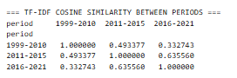
Figure 7: Cosine Similarity Between Periods
Cosine similarity matrix reveals how similar the vocabulary of abstracts are over time intervals. The highest similarity appears between 2011–2015 and 2016–2021 (0.64), indicating gradual transition, while 1999–2010 and 2016–2021 show the lowest similarity (0.33), confirming a major shift from traditional machine learning terminology to deep learning-focused research language.
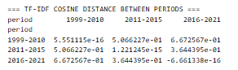
Figure 8: TF-IDF Cosine Distance Between Periods
The cosine distance matrix validates the vocabulary separation through the time. The highest distance is between 1999 to 2010 to 2016 to 2021 (0.67), reflecting the most lexical drift over time. The smallest distance between 2011–2015 and 2016–2021 (0.36) suggests smoother progression, where later research builds upon the transitional growth period rather than changing rapidly.
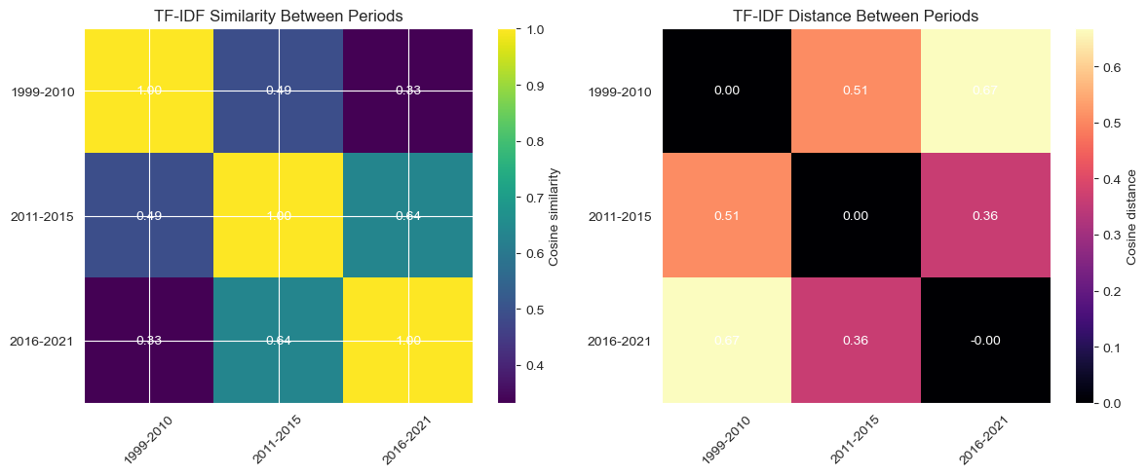
Figure 9: TD_IDF Cosine Similarity and Distance
Such heatmaps are more graphical reinforcements of the TF-IDF results which indicate lexical associations between periods. Higher similarity values and lower distance value values depict an intense closeness. The early and boom periods are distinct, whereas the growth and boom periods are closer, proving that the machine learning research has gradually shifted to more theory-free vocabulary of the neural network and deep learning.

4.2 Experimental Setup
For TF-IDF, both unigram and bigram representations were generated using n-gram ranges of (1,2) to preserve both single keywords and technical phrases such as “neural network” and “support vector.” This improved phrase-level analysis and reduced ambiguity in vocabulary comparison. Mean TF-IDF scores were calculated for each period, and distinctive terms were extracted based on the highest average scores. PCA was applied using two principal components (2D projection) to both TF-IDF vectors and embedding representations so that temporal drift could be clearly visualised in a low-dimensional space. This allowed direct observation of how abstracts from different periods formed clusters and shifted over time.
For BERTopic, the exact embedding model used was SentenceTransformer all-MiniLM-L6-v2 as the baseline model, while all-mpnet-base-v2 was tested as an alternative for stronger semantic representation. UMAP was used for dimensionality reduction, and both HDBSCAN and KMeans clustering were compared. KMeans clustering was selected because it reduced excessive outlier assignments and improved topic stability.

4.3 Results and Comparative Findings

4.3.1 TF-IDF Results
TF-IDF analysis indicated that there was a significant change in vocabulary within the three periods.
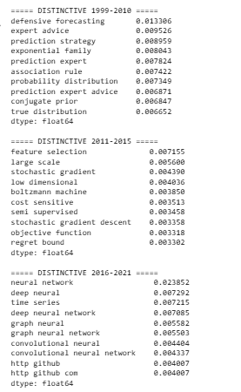
Figure 10: Distinctive Terms by Period
Clear research priorities of every stage of research are represented by distinctive keywords. Learning in early years is concerned with prediction theory and probability, as well as approaches based on rules. The intermediate period emphasizes feature selection, optimisation and semi-supervised learning. Most recent terms consist of neural network, graph neural network, and deep learning terms, and demonstrate the high trend towards advanced representation learning as well as specialised networks.

4.3.2 LDA Results
LDA always demonstrated a shift in the traditional topics of machine learning to the contemporary ones of deep machine learning.
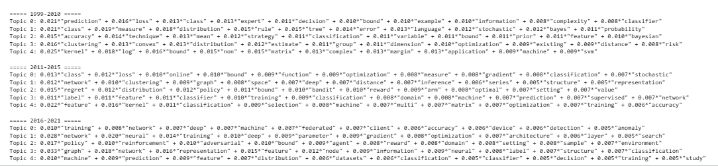
Figure 11: LDA Topics and Top Keywords
Classification, probability, kernels, and optimisation dominate the LDA topics of the early period, and are traditional machine learning foundations. Subsequent ages bring about networks, training, graphs and reinforcement learning. This illustrates how latent themes could develop using theoretical statistical techniques to neural models and application-focused learning frameworks, fostering the temporal dynamics identified by TF-IDF. The topics of LDA grew more related to neural networks, graph learning, and reinforcement learning in later periods. Global LDA models showed that these newer topics gradually replaced earlier classification-based themes.
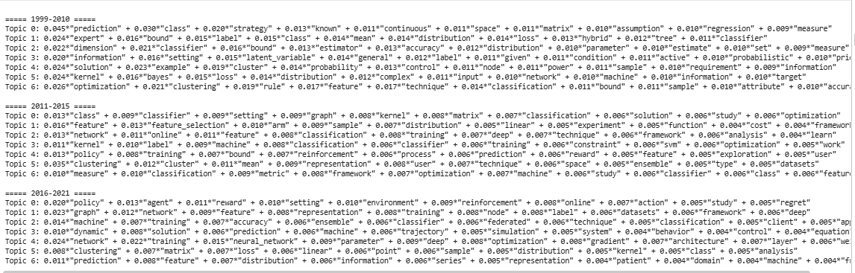
Figure 12: Output after Bigram
This lengthy LDA output offers better testament to the development of the topics in all the periods. Early topics remain focused on classification and regression, while 2011–2015 introduces feature learning and optimisation. Neural networks, graphs, policy learning, and dynamic systems prevail by 2016-2021, confirming the maturity of deep learning and reinforcement-based approaches in current research.
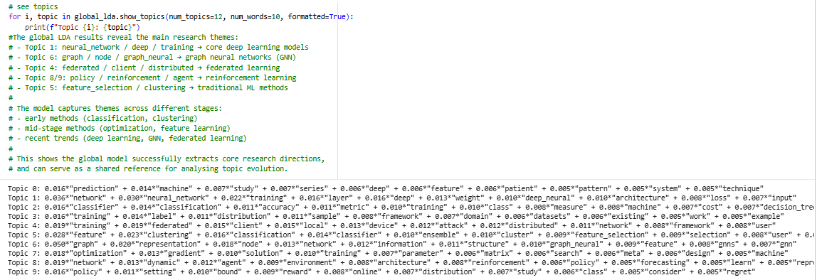
Figure 13: Global LDA Results
The world-LDA model describes the key common themes of research in all the corpus. Neural networks, graph neural networks, federated learning and reinforcement learning are strongly represented, with feature selection and clustering representing earlier foundations of machine learning.
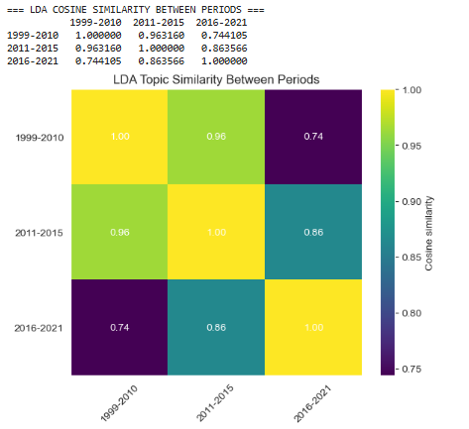
Figure 14: LDA Cosine Similarity Between Periods
The LDA similarity model exhibits a more pronounced level of thematic coherence when compared to TF-IDF since topic modelling reflects a less narrow range of semantic associations. The highest similarity occurs between 1999–2010 and 2011–2015 (0.96), while similarity decreases for 2016–2021 (0.74), indicating that although vocabulary changed sharply, underlying research progression remained gradual rather than completely disconnected.

4.3.3 BERTopic Results
BERTopic resulted in the most semantically coherent and explainable results. Labeling topics was easier and represented clear areas of research like: Graph Neural Networks, reinforcement learning and federated learning.
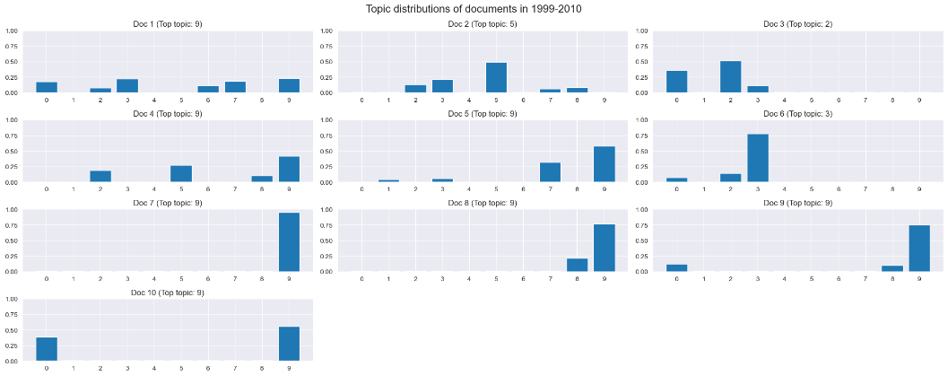
Figure 15: Topic Distribution of Documents (1999-2010)
The early period of documents mostly centers around a few dominant topics, primarily in the area of classification, optimisation and kernel methods. Topics distributions are overly narrow and more theory-oriented and less varied than those seen in the later years which were more application-oriented.
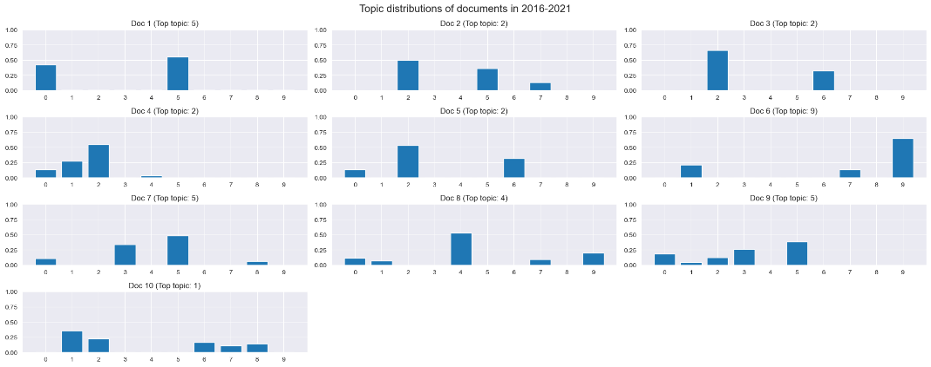
Figure 16: Topic Distribution of Documents (2016-2021)
Later-period documents show wider topic spread across neural networks, graphs, policy learning, and specialised applications. This is the diversification of machine learning research, as deep learning can serve many areas, instead of being connected to a small theoretical domain. It is more applied, broadened and, at the same time, interdisciplinary in nature, as compared to the early stage.
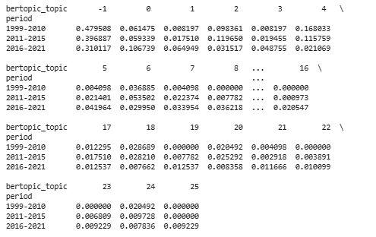
Figure 17: Bert Topic Distribution
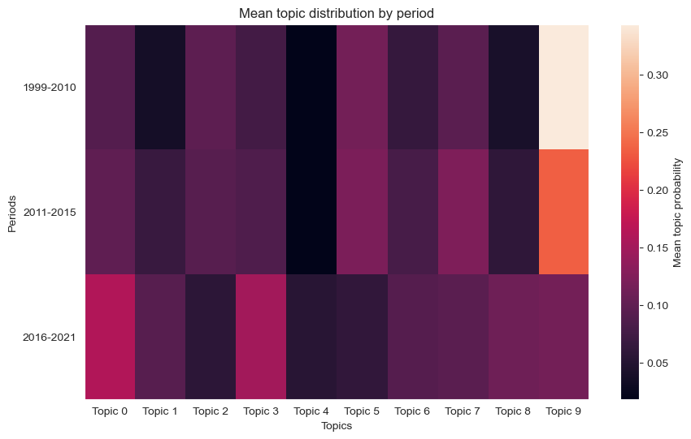
Figure 18: Mean Topic Distribution
The BERTopic heatmap shows how topic importance changes over time. The earlier periods exhibit more probabilities of policy learning, graph, and neural network since the earlier periods were characterized by traditional ensemble, SVM, and kernel-based topics. This is an expression of semantic drift, and validation of the transition of classical machine learning to deep learning and modern specialised machine learning.
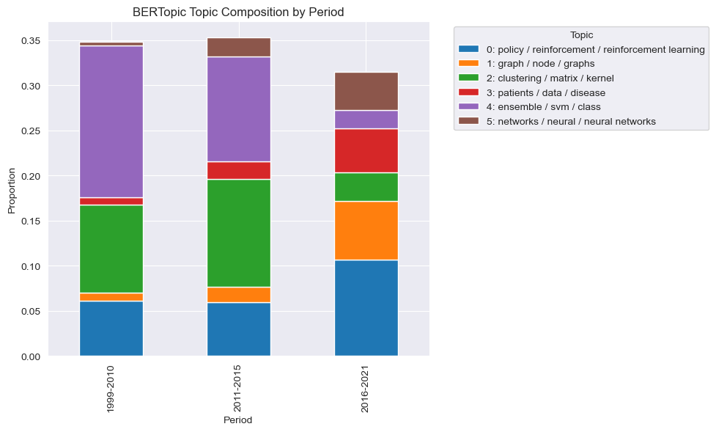
Figure 19: BERTopic Topic Composition by Periods
The stacked bar chart shows the fluctuation in the proportion of the topics over the periods. SVMs, clustering and matrix-based learning are predominant in early periods whilst reinforcement learning, graph methods and neural networks dominate in the 2016-2021 period. This is a clear example of the structural change in machine learning research between classical procedures to that of state-of-the-art deep learning.

4.3.4 HDP Results
HDP has been able to extract the wide range of changes across time without having to select topics manually.
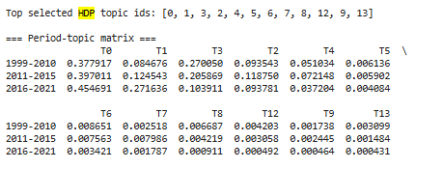
Figure 20: Top HDP Topics IDs
The HDP topic matrix demonstrates the variations of automatically identified topics over time. The prevalence of topic T0 is also the same in all periods, which indicates the presence of stable underlying concepts, whereas the prevalence of topic T1 grows significantly in 2016-2021 which suggests new modern themes. The slow shift of topic weights through its research can be seen as how methodological approaches to machine learning subject change have remained stable across time without completely altering theoretical backgrounds.
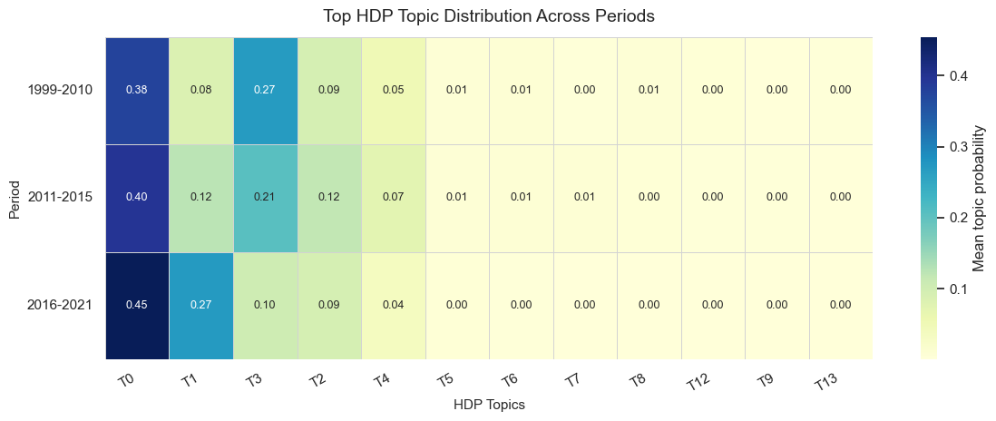
Figure 21: Top HDP Topic Distribution
This heatmap is used to visualise the concentration of the HDP topics over the periods. The theme of intensities in T0 and T1 are the most influential themes, and other weakly distributed themes are small. The emergence of the newer topics in later periods is evidence of modern developments, but a similar generational overlap also explains why HDP topics are more difficult to interpret than either BERTopic or tuned LDA models.
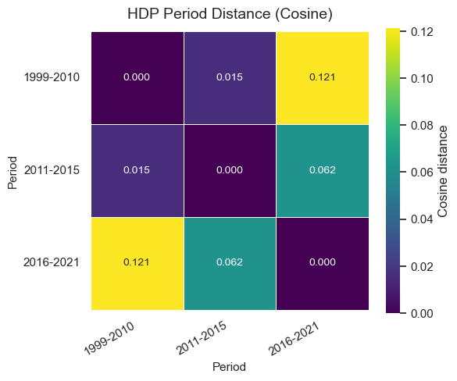
Figure 22: HDP Period Distance
The HDP cosine distance matrix shows the greatest thematic distance between 1999–2010 and 2016–2021 (0.121), confirming strong temporal drift. The smaller distance between 1999–2010 and 2011–2015 (0.015) suggests gradual evolution rather than sudden disruption. This helps to conclude that the machine learning research shifted gradually towards contemporary deep learning topics.

4.4 Error Analysis and Method Limitations
Although the models successfully identified major research transitions, several specific errors and limitations affected performance. The first major issue was topic overlap in LDA and HDP. For example, topics related to “classification,” “optimisation,” and “feature selection” frequently shared similar high-frequency terms such as model, training, and learning. This caused partial overlap where multiple topics appeared semantically similar, making topic boundaries difficult to define. In some early-period LDA outputs, support vector methods and general classification topics were merged rather than clearly separated.
The second issue involved BERTopic outlier assignments. In the default HDBSCAN configuration, a large number of documents were assigned to topic -1 (outlier cluster), particularly in the 2016–2021 period where research themes were more diverse. This reduced topic coverage and weakened comparison across periods. For example, some graph learning and reinforcement learning papers were incorrectly grouped as outliers instead of being assigned to meaningful clusters. This problem was reduced significantly after switching to KMeans clustering. The third issue was ambiguity caused by highly reused vocabulary across different research domains. Words such as “model,” “network,” “learning,” and “training” appeared in nearly all topics, especially in modern abstracts. This reduced topic distinctiveness and sometimes caused misclassification between neural network topics and reinforcement learning topics because both used similar training-related terminology.
Another limitation was interpretability in HDP. While automatic topic discovery was useful, many HDP topics were fragmented and contained overlapping words with weak thematic distinction. For example, T0 and T1 remained dominant across all periods but required substantial manual interpretation to identify whether they represented optimisation, prediction, or classification themes. These findings show that no single method was perfect. TF-IDF was strong for vocabulary drift but weak for semantic understanding. LDA required manual tuning, BERTopic required clustering optimisation, and HDP sacrificed clarity for flexibility. This reinforces the importance of combining multiple methods to improve reliability and reduce the weaknesses of individual models.

5. Conclusions
This study investigated how the focus, framing, and communication of machine learning research have evolved over time through a comparative corpus analysis of arXiv abstracts from the cs.LG category. By dividing the corpus into three periods: 1999–2010 (early stage), 2011–2015 (growth stage), and 2016–2021 (boom stage), the project successfully identified major thematic and lexical shifts in the field. The results consistently showed a clear transition from traditional machine learning topics such as classification, optimisation, kernel methods, and statistical learning toward modern themes dominated by deep learning, neural networks, graph neural networks, reinforcement learning, and federated learning. TF-IDF effectively captured vocabulary drift across periods, showing how research terminology shifted from theoretical concepts to application-driven language. LDA provided stable topic evolution and demonstrated that bigram-based models improved interpretability by producing clearer and more specific topics. BERTopic produced the strongest semantic coherence and the most meaningful topic labels, making it the most effective method for understanding research trends. In contrast, HDP offered useful exploratory analysis through automatic topic discovery but generated fragmented and overlapping topics that reduced interpretability.
The most successful aspect of the project was the use of multiple complementary methods rather than relying on a single model. Consistent findings across TF-IDF, LDA, BERTopic, and PCA strengthened confidence in the results and improved robustness. BERTopic with KMeans clustering achieved the best balance between topic clarity and coverage, while TF-IDF and LDA provided strong transparency and validation. However, some limitations remained. Scientific abstracts are short and highly compressed, often containing technical terminology and overlapping vocabulary, which creates challenges for topic separation. HDP and baseline BERTopic were particularly affected by fragmented topics and outlier assignments. Additionally, topic interpretation still requires manual judgment, which introduces subjectivity. Future work could improve this analysis by incorporating citation networks, full-text papers, or author-level metadata to provide richer contextual understanding. Dynamic topic modelling and more advanced temporal embedding methods could also improve the precision of tracking research evolution over time.

